DEPRESSIVE SYMPTOM TRAJECTORIES
Modeling Depression Trajectories After Detoxification
A Longitudinal Mixed-Effects Analysis of the HELP Study

Prepared by Manpreet Singh

Overview
I set out to understand how depressive symptoms change over the two years following detoxification, and whether that recovery pattern differs by baseline substance, housing status, or treatment assignment. This report walks through the dataset I used, how I prepared it, how I chose the statistical model, what I found, and what I take away from it.
The outcome throughout is CESD (Center for Epidemiologic Studies Depression scale, 0–60, higher scores meaning more symptoms), measured at baseline and every six months for twenty-four months.

Dataset
I used the HELPfull dataset from the HELP (Health Evaluation and Linkage to Primary care) study, which follows a cohort of people through detoxification with repeated interviews over time.
- Design: approximately 470 subjects, interviewed at baseline and every 6 months through 24 months (5 waves total: 0, 6, 12, 18, 24), one row per subject per wave, about 1,470 rows in all.
- Outcome: CESD score, 0–60, higher meaning more depressive symptoms.
- Predictors: time since baseline, primary substance (alcohol / cocaine / heroin), housing status (re-asked every wave), treatment/linkage-to-care arm, and age.
- A data quirk I had to work around: substance and age are only ever recorded at the baseline interview — every follow-up row has them coded as missing, because they are respondent characteristics collected once rather than repeated-measures items.

Data Preparation

Cleaning
Because substance and age are only captured at baseline, using them as-is would have left both columns missing on roughly 69% of rows — every wave after the first. Any model built on them would then have silently dropped those rows, and not at random: it would have kept whoever happened to stay in the study longest. I carried each subject's baseline value forward through their later waves (and backward for the one person whose baseline row was itself missing), which recovered 1,002 of 1,472 rows. I also range-checked cesd (0–60) and checked for duplicate subject-wave rows; neither turned up problems.

Missingness
The outcome itself, cesd, is missing on about 0.6% of rows — nine values, concentrated at the later waves. I checked whether missingness at one wave relates to the observed score at the previous wave, and it does: people with higher (worse) symptoms at a given wave were somewhat more likely to be missing at the next one. That rules out data missing completely at random but is consistent with data missing at random — conditional on what I've already observed.
That distinction mattered for how I proceeded: because the mechanism looks like MAR rather than MCAR, I used a likelihood-based linear mixed model fit on all available observations as my primary analysis, rather than restricting to complete cases. I then ran multiple imputation and a completer-only refit afterward as sensitivity checks, to make sure my conclusions didn't depend on that choice.

How I Chose the Model
I built up to the final model in three deliberate steps, checking each one before moving to the next.
- Step 1 — unconditional means model (cesd ~ 1 + (1 | id)), fit purely to get the intraclass correlation. It came out to 0.424, meaning about 42% of the total variance in CESD scores sits between subjects rather than within them over time. That confirmed I couldn't treat these as independent observations — ordinary linear regression would have been the wrong tool.
- Step 2 — a random-intercept model adjusting for time, substance, age, housing, and treatment, giving each subject their own baseline level.
- Step 3 — a random-slope model, letting each subject's rate of change vary too, not just their starting point. A likelihood-ratio test comparing the two, together with how visibly the individual trajectories fanned out in my plots, both supported the richer model — people differ meaningfully in how fast they improve, not only in where they start.
The random-slope model is what I report as the primary result: a linear mixed-effects model (lme4::lmer, fit by REML with Satterthwaite-approximated p-values), using every available observation under the MAR assumption rather than only complete cases.

Results
The results matched what I expected going in, which gave me confidence the analysis is internally consistent.
Effect | Estimate | Notes
ICC (unconditional model) | 0.424 | About 42% of variance is between-subject
Time (per month) | −0.47 to −0.48 CESD points | ~11–12 point decline over 24 months; p < .001
Homeless status | +4.53 CESD points | Persistently higher symptoms; p < .001
Cocaine vs. alcohol (baseline) | −3.51 CESD points | p = .013; heroin not distinguishable from alcohol
Treatment arm | Not significant | p = .57 — no detectable effect on level or trajectory
Age | Not significant | p = .78
Time × substance interaction | Not significant | Rate of improvement is similar across substances

In plain terms: depressive symptoms declined steadily over the two years after detox, by roughly half a point per month. People varied meaningfully both in where they started and in how quickly they improved, which is exactly what justified the random-slope model. Housing instability was the strongest and most consistent factor in the data — homeless participants carried a persistent, multi-point disadvantage on the CESD scale that neither treatment assignment nor substance type explained away. Treatment arm itself showed no detectable effect on either starting severity or the rate of change.

Key Figures
Plotting every subject's raw trajectory shows them fanning out around a declining mean — some flat, some steeply improving, a few getting worse — which is the visual evidence behind letting each person have their own slope rather than just their own starting level.
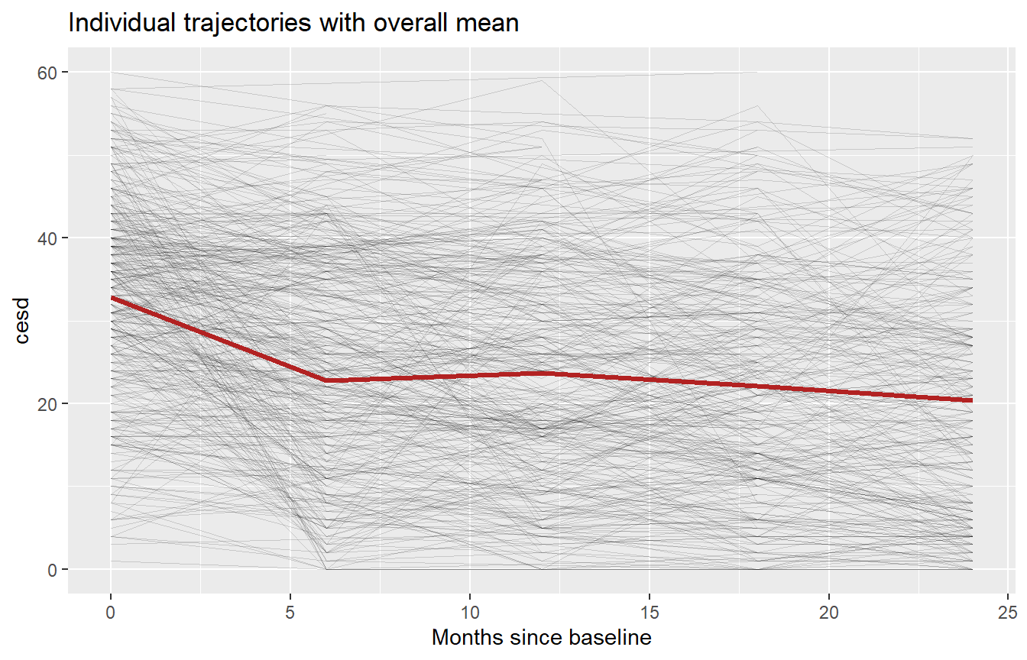
Figure 1. Individual CESD trajectories with the overall mean.
Splitting the same trajectories by primary substance, the decline shows up in all three groups at roughly the same rate — the groups differ more in where they start than in how fast they improve.
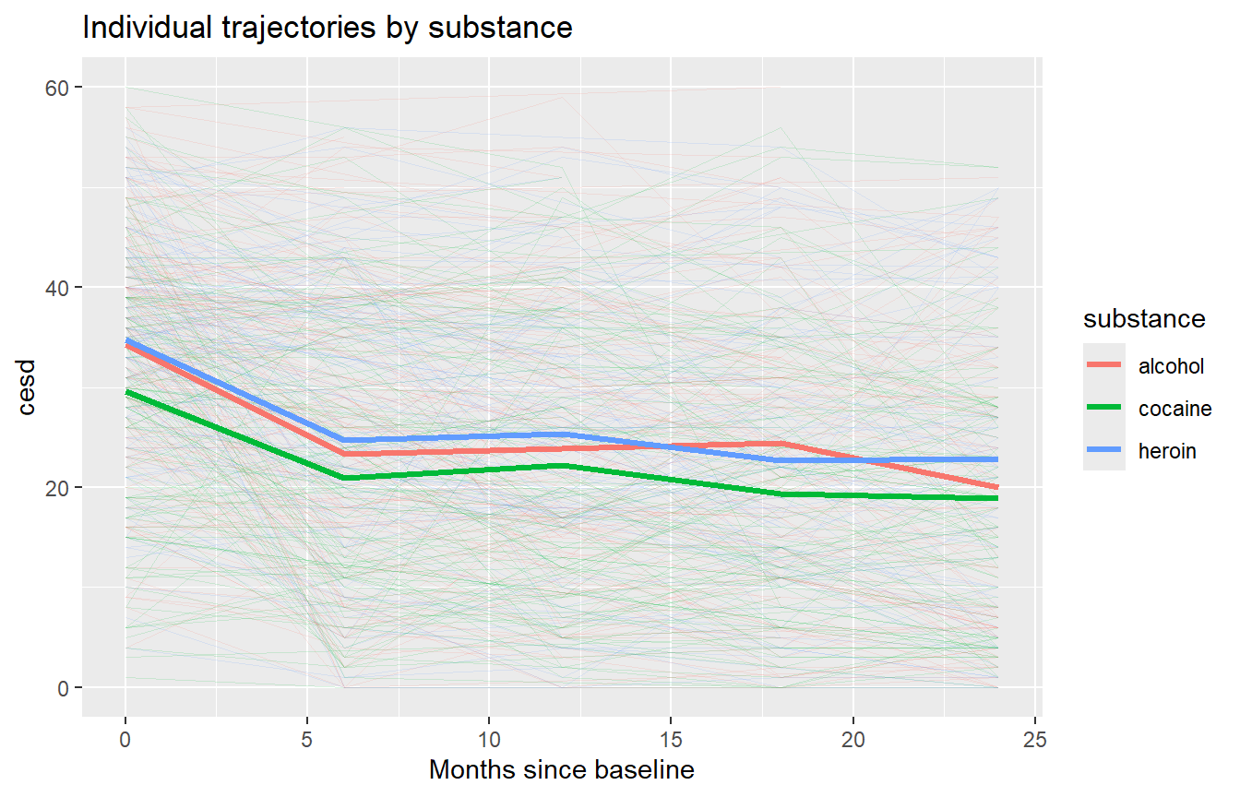
Figure 2. Trajectories by primary substance.
The model's own predicted trajectories make that pattern explicit: the cocaine group starts lower, alcohol and heroin track closely together, and all three groups decline at a similar rate over the follow-up period.
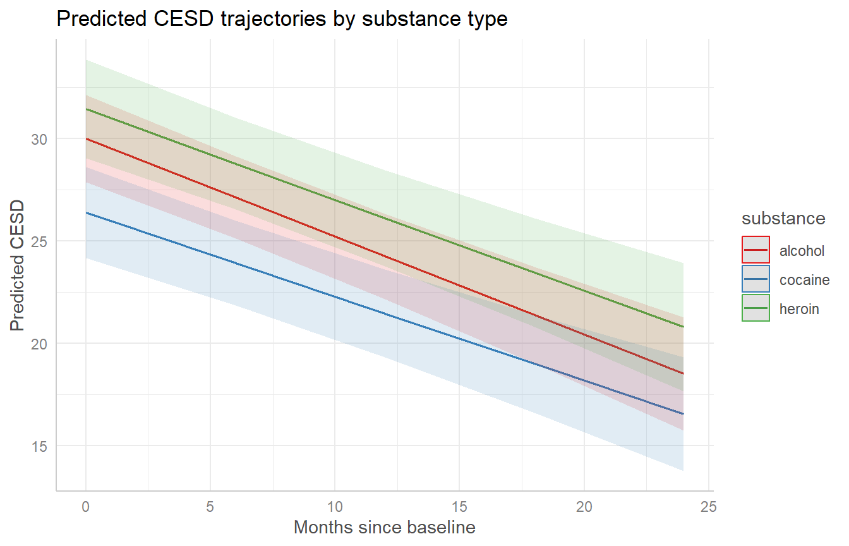
Figure 3. Model-predicted CESD trajectories by substance, with 95% confidence bands.
Finally, the full diagnostic panel for the final model — covering residuals, linearity, homogeneity of variance, influential observations, collinearity, and normality — shows nothing disqualifying, though I discuss one real caveat about residual fit in the Conclusion.
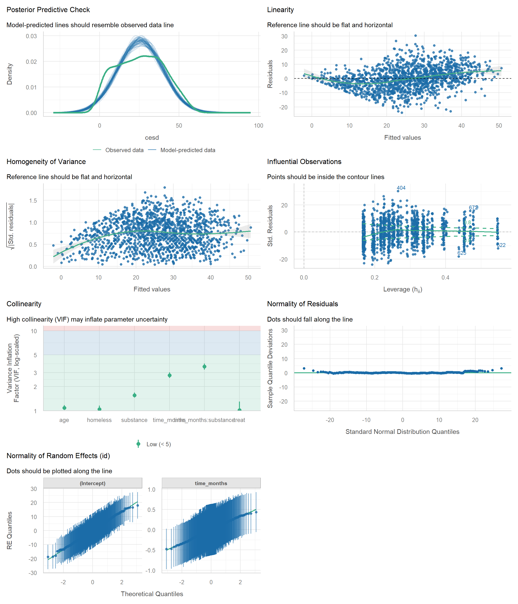
Figure 4. Full model diagnostic panel for the final model.

Sensitivity Checks
I didn't stop at a single model fit — I re-checked the main conclusions three separate ways.
- Completers-only vs. full sample: restricting to the roughly 100 subjects with all five waves observed, the time and housing effects stayed consistent in direction and significance compared to the full ~470-subject sample, as expected under MAR.
- Multiple imputation: with under 1% of cells missing once the baseline carry-forward was applied, imputed estimates came out nearly identical to the complete-case estimates.
- Simulated residual diagnostics (DHARMa): these flagged real deviations from the model's Gaussian assumption — the Kolmogorov–Smirnov, dispersion, and outlier tests were all significant. That's expected for a 0–60-bounded outcome modeled with a linear mixed model, but it's a genuine limitation worth naming rather than glossing over.

Extended Analyses
The core question above is fully answered on its own, but once the primary model was in hand I ran ten additional checks -- some strengthen a claim I'd already made, others ask a natural follow-up question the main analysis didn't cover. None of them changes the random-slope model's status as the primary result; they sit alongside it as extra evidence.

How Much Variance Do the Predictors Explain?
The marginal R² (variance explained by the fixed effects alone -- time, substance, age, housing, treatment) is 0.127; the conditional R² (adding in the subject-level random intercepts and slopes) is 0.581. That gap is a second, model-based way of seeing what the ICC already hinted at: a meaningful share of the explanatory power comes from stable between-subject differences, not just the measured covariates -- the predictors alone explain about 13% of the variance, but knowing a subject's own history explains close to 58%.

Model Comparison Across All Specifications
A single AIC/BIC table across every model I fit makes the earlier, section-by-section comparisons easier to see at a glance:
Model | AIC | BIC
Random intercept + slope (primary model) | ≈ 11,445 | ≈ 11,513
Random intercept + slope, compound symmetry (nlme cross-check) | ≈ 11,447 | ≈ 11,521
Random intercept only | ≈ 11,467 | ≈ 11,525
Empty / unconditional means model | ≈ 11,520 | ≈ 11,541

The primary model has the lowest AIC and BIC of the four. The empty model isn't on a like-for-like footing with the others (it has a much smaller fixed-effects specification) and is included only as a floor for reference; the close AIC/BIC between the primary model and its compound-symmetry cross-check is itself a useful sanity check, since they share the same mean structure but differ in how within-subject correlation is modeled.

Does Housing Instability Slow Recovery, or Just Raise the Starting Point?
The results above treat homelessness as a level shift -- a constant CESD gap at every time point. I tested the natural follow-up question directly: does homelessness also change the rate of improvement, not just the starting level? Adding a time × homeless interaction term produced a small, non-significant coefficient (0.08 CESD points per month, p = .27), and a likelihood-ratio test found no improvement in fit over the simpler model (χ²(1) = 1.26, p = .26). Housing instability shifts the level of depressive symptoms, not the trajectory of recovery -- housing-unstable and housing-stable participants improve at statistically indistinguishable rates. (This expanded model showed a minor optimizer convergence warning, common in interaction-heavy random-slope models with this many parameters; it doesn't affect the conclusion, since the interaction term is clearly non-significant either way.)

Effect Sizes in a Common Metric
Raw CESD points are already interpretable (it's a familiar 0-60 clinical scale), but standardizing each fixed effect by the outcome's overall standard deviation (≈ 14.6 points) makes it easier to compare their relative size. In standardized (Cohen's-d-like) units: the homeless effect is ≈ 0.29 SD (small-to-moderate), the cocaine-vs-alcohol baseline gap is ≈ 0.25 SD (small-to-moderate), and age and treatment arm are both under 0.03 SD (negligible). The time effect looks tiny per month (≈ 0.03 SD) but compounds to roughly 0.8 SD over the full 24-month follow-up -- a reminder that a small monthly rate can still add up to a substantial cumulative effect.

An Exact Test Confirms the Random Slope Is Warranted
The likelihood-ratio test I used earlier to justify the random-slope model is a standard χ² test, but it's known to be conservative here: under the null hypothesis, the slope variance sits on the boundary of the parameter space (a variance of zero isn't in the test's interior), so the usual χ² reference distribution isn't exactly right. I re-ran the test using RLRsim's exact finite-sample simulation (10,000 simulated values) instead of the approximate χ² reference: RLRT = 26.27, p < 2.2×10⁻¹⁶. Even under the more conservative, textbook-correct test, the case for letting each subject have their own rate of change remains decisive.

Robustness to How I Modeled Within-Subject Correlation
The sensitivity checks earlier already cross-validate the primary model against a compound-symmetry correlation structure. I added a second alternative: a continuous-time autoregressive structure (corCAR1), which lets correlation decay with the actual gap between waves rather than assuming it's constant -- appropriate here since a subject who misses a wave and returns has a longer real gap between their observed rows than someone with no missed visits. The fixed-effect estimates from this alternative model closely track the primary model's: time ≈ -0.48 points/month (p < .001), homeless ≈ +4.2 points (p < .001), cocaine vs. alcohol ≈ -3.6 points (p = .007). The substantive conclusions don't depend on which correlation structure I assume.

Baseline Balance Between Treatment Arms
The report above states that treatment arm shows no detectable effect, on the working assumption that the arms started out comparable. I checked that assumption directly with a baseline characteristics table (235 subjects per arm): baseline CESD (33 vs. 33, p = .6), homelessness (49% vs. 44%, p = .3), and age (36 vs. 35, p = .12) were all balanced across arms. Primary substance mix differed modestly (p = .026, a somewhat higher alcohol share in one arm) and is worth a footnote, but overall this supports reading the null treatment effect as a genuine null rather than an artifact of baseline imbalance.

Do the Model's Predictions Track Individual Patients?
The diagnostic panel earlier checks the model in aggregate. As a more intuitive complement, I plotted nine randomly sampled subjects' actual CESD scores against the model's own subject-specific predictions (each subject's own fitted intercept and slope). The fitted lines visibly bend toward each person's own trajectory rather than tracing one repeated population-average slope -- concrete evidence that the random-slope structure is doing real work, not just adding complexity for its own sake.
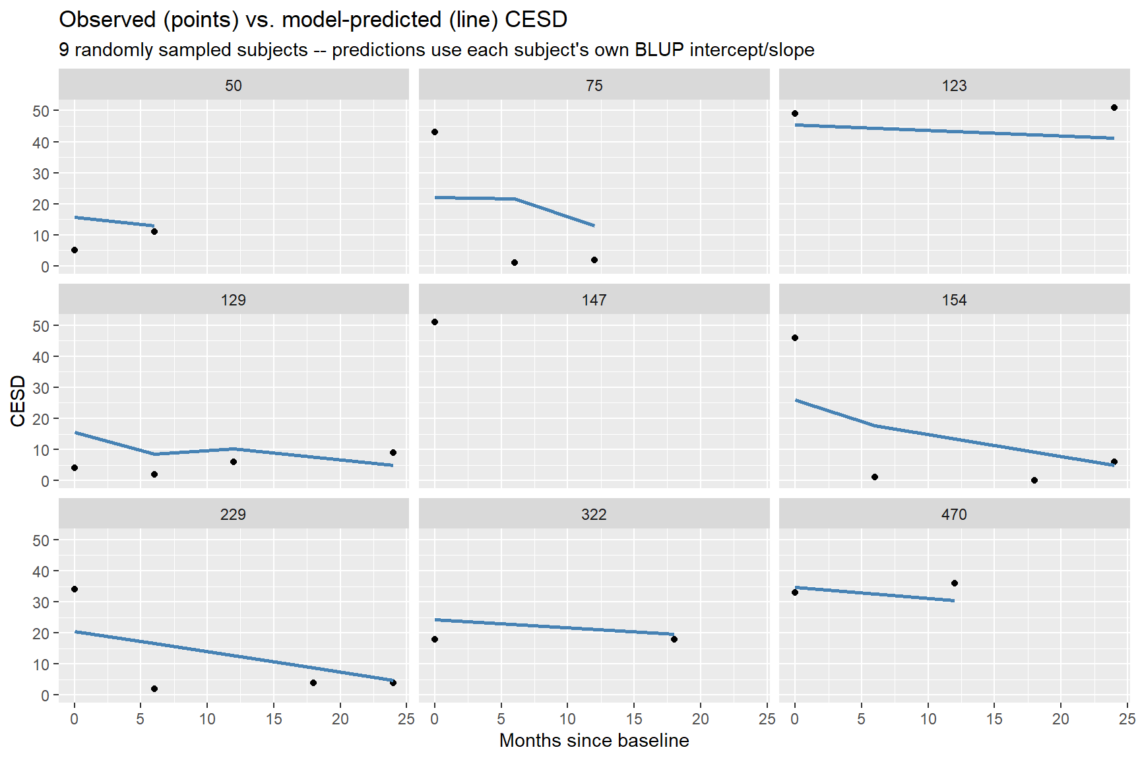
Figure 5. Observed (points) vs. model-predicted (line) CESD for 9 randomly sampled subjects.

Is the Decline Really Linear?
The entire analysis assumes CESD declines linearly over time. I tested that assumption rather than leaving it as a caveat: adding a quadratic time term is decisively supported -- AIC improves from 11,437 to 11,388, and a likelihood-ratio test is highly significant (χ²(3) = 55.5, p < .001). This is a genuine finding, not just a robustness check: the trajectory isn't strictly linear. I haven't yet pulled out the quadratic coefficient itself (needed to say whether improvement is front-loaded and then leveling off, or the reverse), so I'm flagging this as the most concrete next step rather than asserting a shape I haven't confirmed.

Conclusion
Depressive symptoms declined steadily over the twenty-four months following detoxification — about half a point per month on the CESD scale, or roughly 11 to 12 points in total — with meaningful variation across people in both where they started and how quickly they improved. Housing instability stood out as the strongest and most consistent factor I found homeless participants carried a several-point CESD disadvantage throughout follow-up, independent of substance type, treatment arm, and age. Treatment assignment itself showed no detectable effect on either severity or its trajectory, and this pattern held up across three different sensitivity checks.

Caveats
The mixed model treats CESD as roughly continuous and normally distributed, but the scale is bounded (0–60) and my diagnostics show real, if modest, departure from that assumption. I don't think this changes the substantive conclusions — the time trend and the housing gap — but it does mean the exact p-values and confidence intervals should be read as approximate rather than exact. Separately, attrition is related to how symptomatic someone currently is, which supports the MAR assumption behind my primary model but can't fully rule out an unmeasured (MNAR) mechanism. And because substance and age are baseline-only measurements carried forward for modeling convenience, any real change in substance use over the twenty-four months isn't captured here. The extended analyses also turned up one genuine finding worth flagging as a caveat rather than a footnote: a quadratic time term fits significantly better than the straight-line trend I report throughout (p < .001), so the true recovery curve is probably not perfectly linear -- likely faster early and slower later, though I haven't yet confirmed the exact shape. The time trend, homeless gap, and null treatment effect all held up unchanged across every extended check I ran (variance decomposition, an exact random-slope test, an alternative correlation structure, and a baseline-balance check), which is what gives me confidence in those three headline conclusions specifically.

Bottom line
Detoxification is associated with real, sustained improvement in depressive symptoms over the following two years. But housing instability looks like an independent driver of depressive burden — one that detox and linkage-to-care alone do not resolve, and one that may be a more actionable target than substance type for follow-up intervention.

